(12) **United States Patents** C:\Users\VarshaDwajan\Downloads\image.png

(10) **Patent No.: US 2,408,905 A1**

(45) **Date of Patent: Dec 4, 2014**

(52) **E-Wash**

(75) Inventors: **Varsha Dwajan**(IN), **Sai Tadimeti**(IN), **Soumya Veer**(IN), **Sharath Chandra**(IN), **Sriteja Aluri**(IN), **Sriram Gorantla**(IN).

(73) Assignee: **University Of Houston, Houston**, TX (US)

(*) Notice: Subject to disclaimer, the terms of this patent is extended or adjusted under 35 U.S.C 154(b) by 0 days.

(21) Appl. No. : **08/412,201**

(22) Filed: **Dec. 4, 2014**

(51) **Int CL**………………………………………………..**G08B 23/00,** A61B 5/103

(52)U.S CL…………………………………………………600/595, 340/573;540/573.5.

(58) Field Of Search …………………………………. 340/573.5,573.6,245.9,666,667,310.01,310.05

(56) **References Cited**

**U.S PATENT DOCUMENTS**

*(Needs to be filled)*

**ABSTRACT**

There is provided herein an electronic patent technology that is applicable to a wide range of queuing systems. The technology is described for eliminating wait time in a laundry system. The technology consists of hardware and a software. When a person wants to use a common laundry, he/she will have to login to his/her account and books a time slot for washing the clothes. If the times and number of dryers will be available than the slot will be booked, else it will give the message asking the user to either get into the queue or choose another laundry which is free. Depending on what the user chooses the system will give information to the user telling him/her how many minutes are left for his/her slot of washing or drying. Now, assume that the users slot arrives. At this time, user will carry his/her RFID card to the Laundromat and swipe it in the slots to block the machines and the amount of money is already deducted from his /her account for washing and drying of clothes. This is how the said technology works to eliminate queue.

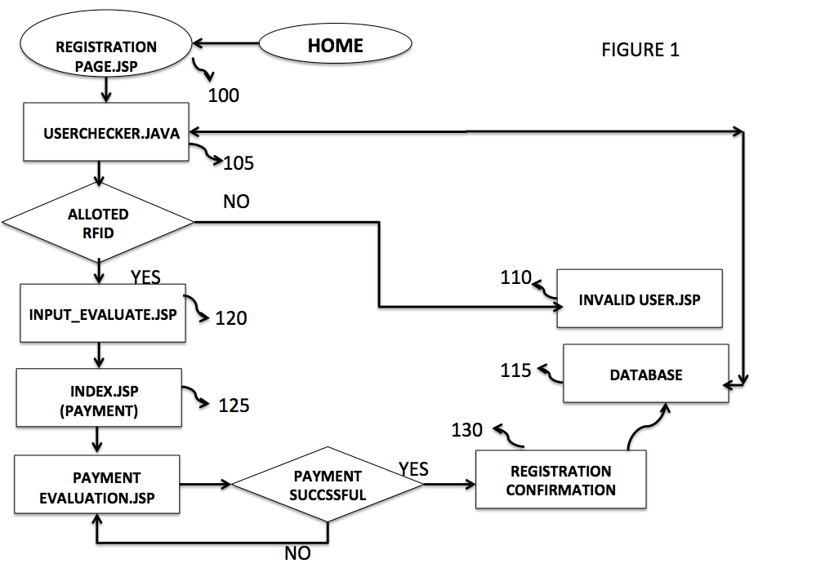

**FIGURE 1**

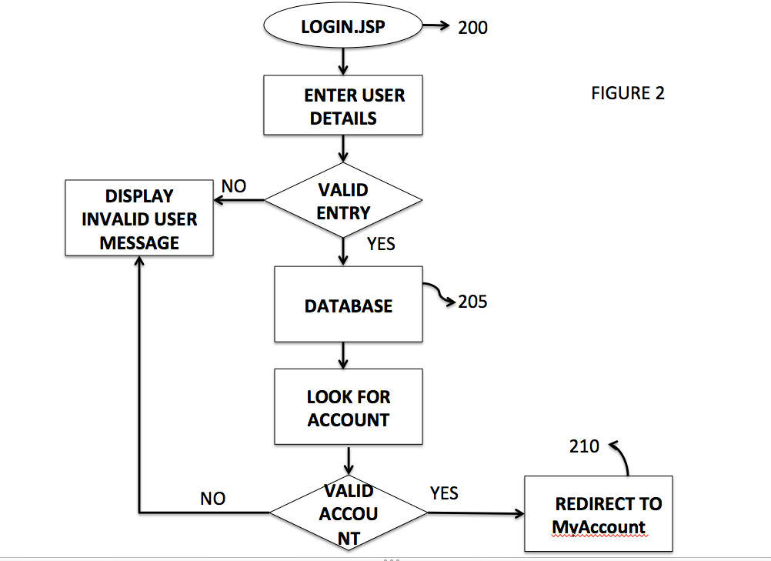

**FIGURE 2**

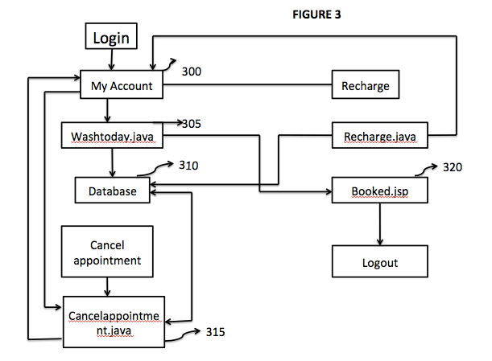

**FIGURE 3**

**FIELD OF THE INVENTION**

This invention mainly relates to monitoring the queue systems, regulating a specific order optimizing time and cost. This system is implemented on a laundry system to regulate the queue to machines, and optimize the washing times and reduce the waiting time of personnel to the minimum. This system is equipped with an RFID using, which, a personal can securely pay for the laundry service.

**BACKGROUND OF THE INVENTION**

Laundry is one of those monotonous chores that unfortunately cannot be avoided, especially for people who live in a housing community that has a common washing area or make avail of Laundromats or Washeteria. A person sometimes spends half a day in getting their laundry done, in an era where the Internet connects to everything and everyone in every corner of the nation. From various studies done, it is observed that sometimes an individual spends more than half a day just trying to find a machine to wash the clothes or to dry them.

A person spends countless hours and wastes energy and loses peace of mind. Moreover sometimes, a person may forget to put on the timer to return and remove the clothes from the washer or put it into the drier. This not only causes a hindrance but also causes distress to others.

This is a major problem for the elderly as they find it difficult to keep walking back and forth between the Laundromat and their house just to check for a machine that is free.

There are other scenarios where a user travels outside the community to use a washing area, but may observe the all the machines are occupied and might have to travel to another location. This is not only a waste of time but also fuel and money.

Another disadvantage is that when a user accesses these machines, the user has to carry coins of the exact value such as quarters to do the laundry, it is not always comfortable to keep carrying around quarters.

Keeping all this in mind, E-wash has developed a technology that optimizes the washing time, making it more user friendly and providing maximum comfort.

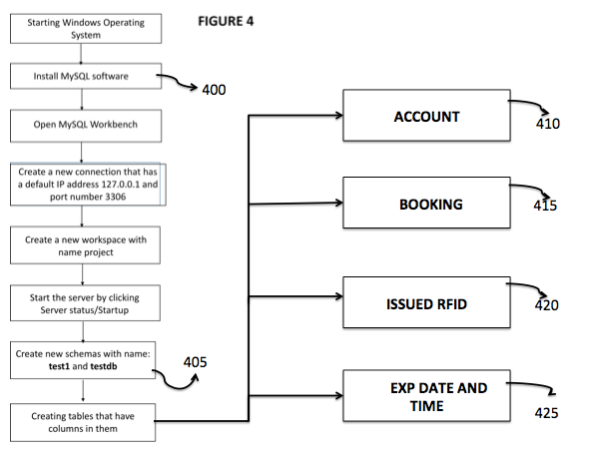

**FIGURE 4**

This technology resolves all this issues by providing the users with an optimum technique where in the user can access a website, register themselves, make avail of facilities like login, booking a slot for washing and drying and making use of an RFID card to make payments.

The website gives the user the information about which laundry area, contains the machines that has been allotted and also the wait time and the total time for washing. The issue of carrying the coins for washing is altogether eliminated with the implementation of the RFID by tapping the card to access the machine.

Before proceeding to the detailed explanation, it should be noted that the diagram along with detailed description should not be constructed to limit the invention to examples.

**SUMMARY OF THE INVENTION**

The summary of the invention is described as follows. The preferred embodiment consists of both hardware and software components that are interweaved with each other seamlessly. The following description is how the preferred embodiment works to optimize the laundry system.

The avail the services of the preferred embodiment, the user must go to the company website and will be provided with the home page.

The home page consists of navigation links to all the pages the embodiment offers. The following pages are linked from the home page, Login, Registration, and Contactors.

The Registration page is for users who do not have an RFID. The user then registers himself by entering all the details.

The login Page consists of the user ID and the password field that allows the user to enter their account. The My Account page consists of the booking slots, so that the user can book time slots and also to balance enquiry and recharge the card. The user can also cancel the account.

Then the user can log out. When the user logs out the user has the knowledge of the machines booked, the booking time, the calculated wait time and the balance on his card.

These data is updated in the database that is creating for the embodiment. The database has a list of fields that is explained in detail in the subsequent. The fields keep a track of the all the data that the user enters and compares them to check the validity of the information.

Another critical part of the embodiment is the RFID. The RFID card that the user consists of a unique tag that identifies the user and also the balance on the card. That gets deducted every the user accesses the washing area. This technology has been implemented using the Raspberry Pi to handshake between the server and program the ID.

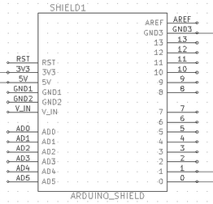

The following sections give a detailed description of the working of the preferred embodiment. Along labeled figures go hand in hand with the explanation to aptly describe the technology of the preferred embodiment.

**BRIEF DESCRIPTION OF THE DRAWINGS**

Other objects and invents will become apparent upon reading the following detailed description of the invention with reference to the drawings which are

Fig 1: Describes the internal flow of the home Page.

Fig 2: Describes the login page.

Fig 3**:** Describes the My Account Page

Fig 4: Describes the creation of databases

Fig 5: Pin diagram of RFID

Fig 6: Handshaking Process between the server and the Raspberry Pi

**DETAILED DESCRIPTION OF THE INVENTION**

According to the present invention, it has the integrating features of all the software with hardware. The preferred embodiment consists of various software’s that along with the hardware forms the complete technology that solves the issues of the user.

**GENERAL BACKGROUND**

The general background of the preferred embodiment is described accompanied along with the figures describes how the technology works. The first page that the user accesses is the home page.

The user enters their details as soon as the user enters the home page. The user is redirected to registration page servlet **100**. The user checker pages **105,** checks if all entries are valid **120.** If valid then the check if the user is allotted a RFID. If the user is not allotted an RFID, then the invalid user page **110** is displayed. If yes, then the user is directed to the payment page. If the payment details are valid then the payment **125** gets processed. If the payment is not processed then its reverted back to payment evaluate page. Once the registration is confirmed, the database **115** is updated with all the details.

The next page that the user accesses after registering the account is the login page. When the user enters the loginpage.jsp 200**, which** is a servlet. The user is asked to enter the login details. It goes to the user checker; if the login details are valid it goes to the database **205**. The database consists of all the updated values of the table. If not it goes on to display the error message. In the database it looks for the account of the user. If the account details matches, the user is redirected to the My Account page. Else the user is displayed with an invalid user page **210**. This page displays the error message.

Once the user has logged in, the user must go to the account page to book slots. The preferred embodiment is explained. The account page **300,** consists of the slots the booking cancellation and logout options. The account page then accesses the washtoday.jsp servlet **305.** This servlet consists information about slot booking. Once the slot is booked the database **310** is updated. The database consists of all the information about the user. The booked.jsp **320** is now updated with the slot. The user can recharge the RFID by accessing the recharge.java page. The user can also cancel the appointment. Accessing the cancelappointment.java 315 does this. The database **310** is updated by deleting the appointment. Once the user is done, the users can logout of the account.

The various database tables that have been accessed are created using MySQL. This integral part of the technology works behind the scenes to bolster the GUI. The MySQL is first installed **400.**  MySQL is an open source RDBMS. The work bench is opened along with the IP address and the port address of the host. A new connection is started and new schemas test1 and test.db are created **405**. The schemas contain the workspace to create tables. The tables this preferred embodiment uses is the account **410**, the account table consist of last name, first name, profile, password, RFID, email, Balance and contact the booking table **415** consists of RFID, slot, status**. The** exp date and time **420** consists of expiry date and time, and the issued RFID **425** consists of the last name first name and the RFID.

The final step to integrate is to Raspberry Pi with the server which is done by the handshaking process. The Pi is connected to the LAN and the necessary peripherals using the pin diagram shown in **Fig5**.

When a user accesses the washing area, and taps his RFID. The following happens: The Raspberry Pi 600 accesses the database 605. The database consists of a booking table 625 whose fields are RFID, SLOT and STATUS. When a user selects the time slot. The RFID of the user gets stored along with the status as 1. Status 1 predominantly means that the status is pending. The apache tomcat 610, this a server is basically automated to perform the following function. The are two integral components the servlet context listener 615 and the scheduled context executer 620. They get triggered as soon as the web pages are accessed. When the user taps the card, the request is serviced. The database table gets updated and the status is now set to 0. When the status is 0 the database accesses the accounts page, the calculated amount is deducted. The scheduled context executer 620 subsequently deletes that entry from the database.

The servlet context listener 615 and the schedule context executer 620 shuts down once the web pages is closed.

Now when the user taps the card, the time comparison is done behind the scenes so the user can accurately access the machines and cost reduction is performed validly.

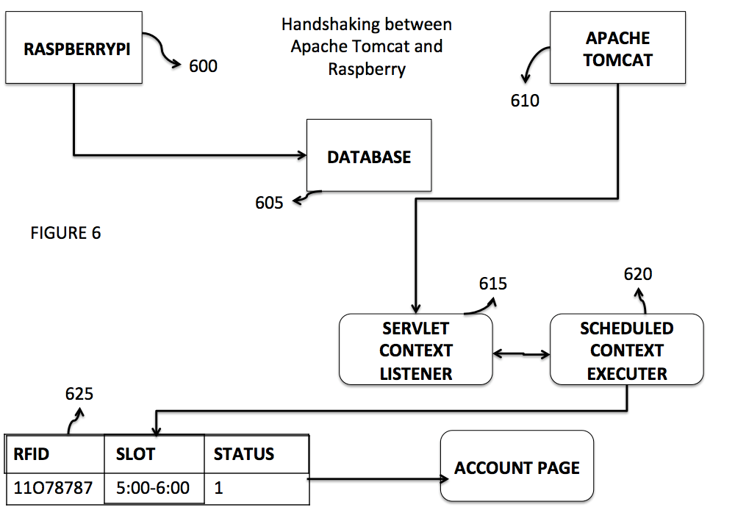

**CONCLUSION**

The preferred embodiment now performs the described function of optimizing the washing technology. The user can remotely book the slot, chose the machines required and estimate the total time and the wait time of using the washing area. This preferred embodiment is subjected to updates that the company is rigorously working on. The user can also get constant updates on the phone as well to determine when the washing or drying is done.